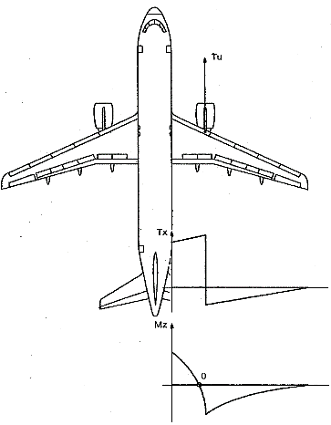

Flexion

M=0

Mmax

Compression

Traction

Compression

Traction

Mmax